# The Road to Rome: East Coast

Places mentioned in this post:

Ravenna, Italy

Classe, Italy

Pesaro, Italy

Ancona, Italy

Rome, Italy

HERE IS THE DRONE LINK that I promised to share from our recent hike to Cinque Torri:

https://www.youtube.com/watch?v=OokFDjKTCPA&t=8s

Man, I miss that place. It was so incredibly beautiful up there.

I was sick for several days after our friends, the Garners, left Italy. I had a scratchy throat that was so raw that it felt like someone had taken a metal rake to it . . . I had several other symptoms, too, but it was a long week where I just laid suuuuper looooow.

Near the end of that week, while I was still rebounding from being sick, Scott and I embarked on a road trip that would last for 5 days. We had been planning it for several weeks and we were excited to see some new places on our way down to the Rome Temple and back.

Day One:

Our first stop was to drive to Ravenna, a little over 2 hours SE of Vicenza. It's a beautiful old town on the Adriatic Coast (archaeological evidence goes as far back as the 5th century BC), and is known for its mosaics. On the drive, I was captivated by the rays of sunlight filtering down through the clouds. It was all very comforting to me, to be riding as a passenger and to just relax as someone else did the "hard stuff". I enjoyed looking out my window and not thinking about very much at all.

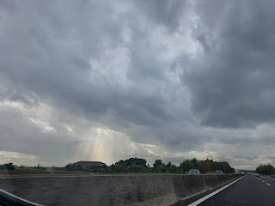

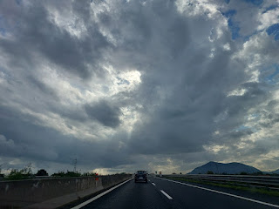

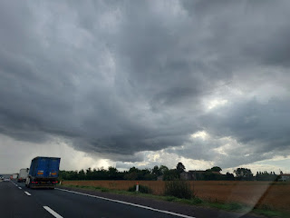

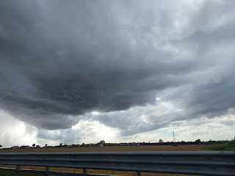

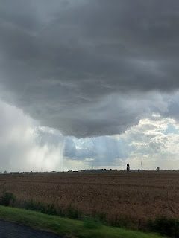

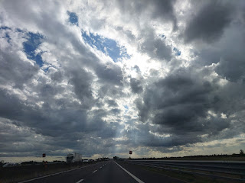

We stayed in a little hotel with a built-in restaurant in Classe, a very small township on the outskirts of Ravenna. The draw for this hotel is that it's right next door to one of the oldest churches in the area with some incredible mosaic work (Sant' Apollinare). We would be visiting there the following morning . . .

Each place we stayed during this road trip had its pros and cons. For this place, Hotel Classensis, the pros were: the location (next to the old sanctuary) and the quietness that came with being out in the countryside. The cons were: the room was stuffy and the A/C didn't work.

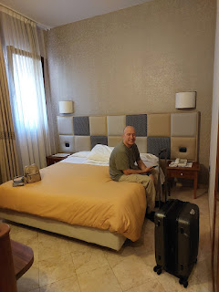

The bathroom was pretty fancy, though, with the brass fixtures. Even the bidet looked fancy!

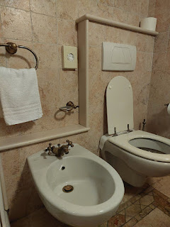

After we dropped off our stuff, we drove into Ravenna to visit the Basilica of St. Vitale. I absolutely loved the walkability of Ravenna. Parking felt easy to find, and the streets were relatively quiet. We only had to walk about 5 minutes to get from the parking lot to the Basilica, passing a very focused street artist along the way.

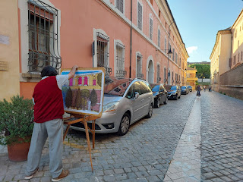

This is the Basilica di St. Vitale. Construction began in 526 AD and was consecrated in 547 AD. It is INCREDIBLE to consider that something this old is still standing today. Even more remarkable, at least to Scott, was their use of bricks! He was astounded that they even had the technique and capabilities back then.

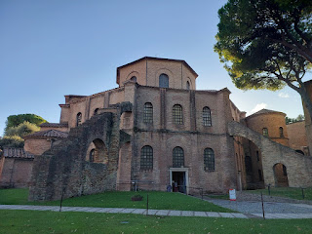

An old tomb that now sits in front of the basilica . . . I loved the lamb motif . . .

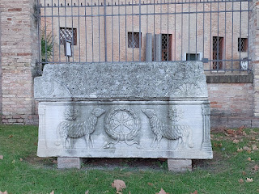

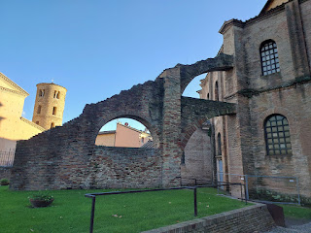

Two signs that 1) describe the construction of the Basilica, and 2) provide information relating to the mosaic designs inside . . . (click photos to enlarge and read)

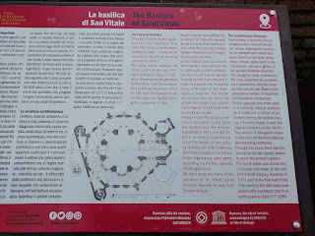

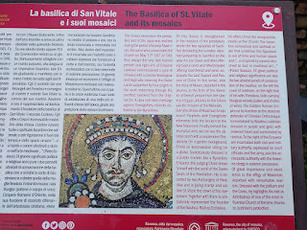

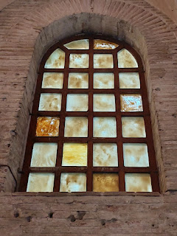

Video walking into the chapel: (10 seconds)

https://photos.app.goo.gl/QNTQCyhuHDhkvJsLA

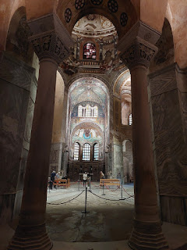

Video of the beautiful mosaics on the floor, too: (10 seconds)

https://photos.app.goo.gl/s6sfm76qVF13ik45A

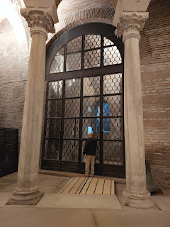

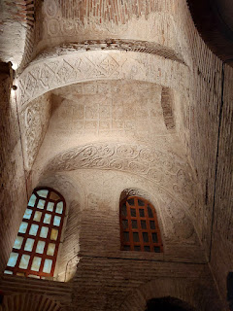

A recovered mosaic panel . . .

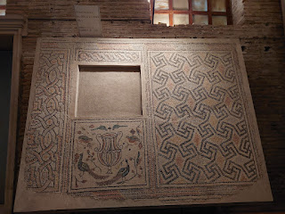

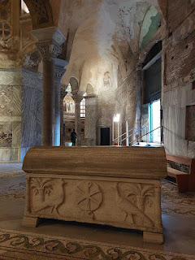

A recovered piece of what appears to be a fresco painting . . .

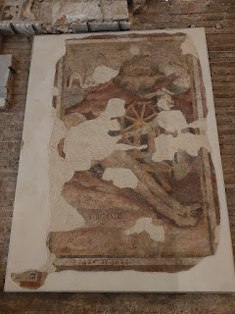

This is what used to be the original entrance to the Basilica . . .

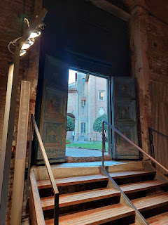

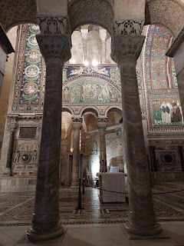

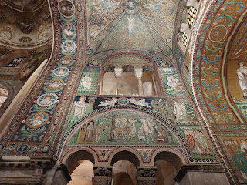

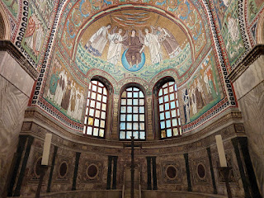

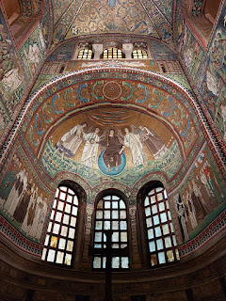

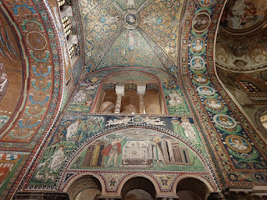

In the photo above, note the circular mini-portraits of some of the original Apostles on the right.

Here is a video of the Apostles up closer: (7 seconds)

https://photos.app.goo.gl/rKDvE6kifuyhadVZA

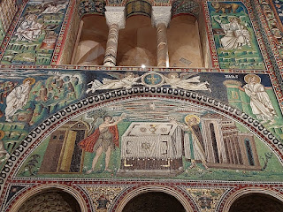

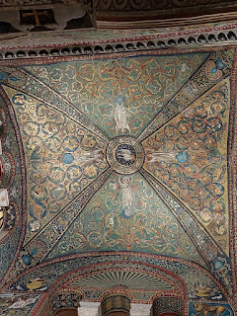

Video showing the front of the chapel in its entirety (and majesty of the mosaics): (30 seconds)

https://photos.app.goo.gl/GCmcuZ63sPSjYJqk6

For a more thorough description of the mosaic panels and what they represent, this is a good website:

https://www.thebyzantinelegacy.com/san-vitale

*Just scroll past the massive paragraphs at the top until you start seeing the photos. I liked reading what the mosaic representations are in each section in the chapel.

I REALLY loved the floors . . . they reminded me of some beautiful quilts I've seen in the past . . .

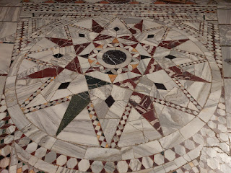

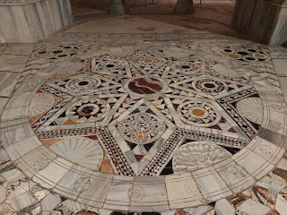

And the arched ceiling was my favorite of all . . .

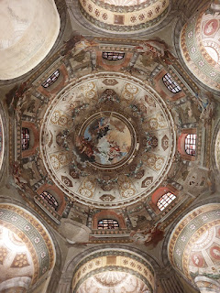

It was exquisite in its detail, but it also reminded me of the kaleidescope I used to play with at my grandparents' house when I was a little girl . . .

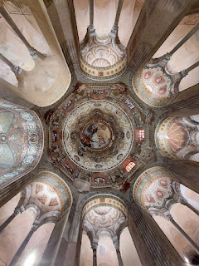

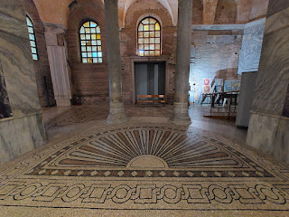

A few years ago they had a celebration of sorts, and some of the locals made a replica of a few scenes inside the Basilica. Below: The lion on top was the original, and the lion underneath was a recent replica. Sitting on the table, you can see a few of the colored tiles that were used . . .

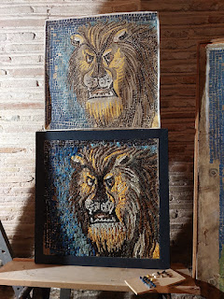

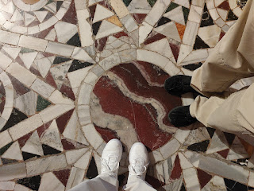

What a beautiful place! So full of history and activities and feelings and special events. I'm so glad we were able to see such a unique place and to learn a little about its long history.

One of the features that my friend, Rachel McGovern, had told me about (because it made such an impression on her) was the

font

. Normally you don't see a giant font in churches other than mine (The Church of Jesus Christ of Latter-day Saints). Many traditional churches perform baptisms in the form of sprinkling and therefore the font is much smaller, more like the size of a drinking fountain.

Here is the font inside the Basilica of St. Vitale . . .

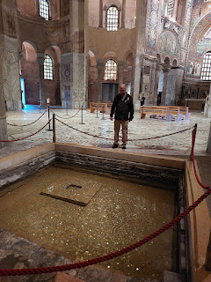

Video of the font with all of its recent gold coins: (11 seconds)

https://photos.app.goo.gl/Mc8ga1jdZV2fsz6MA

A close-up of one of the doors on the original entrance . . .

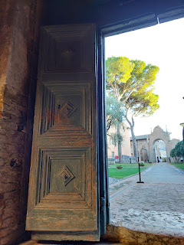

The outside view of that same original entrance . . .

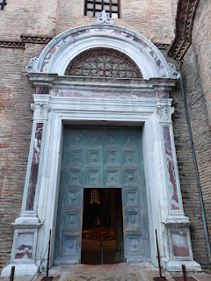

Back in this corner, tucked just out of sight was a tower that looked like it could have belonged to Rapunzel . . .

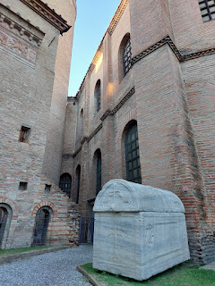

Video of "Rapunzel's Tower", ha ha: (6 seconds)

https://photos.app.goo.gl/s6iPSyVsMhH3kbsaA

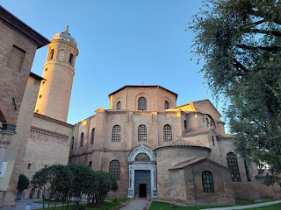

The cobblestone street that leads straight out from the Basilica has several little shops, including cafes, and the ticket office (with a bookstore that had this weird little children's book).

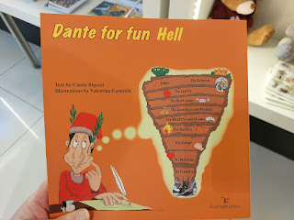

Granted, Dante was an Italian born poet, who was also a moral philosopher and political thinker. He wrote the famous "Divine Comedy", which describes a fictionalized version of himself traveling on a journey back to God, first going through Hell as he learns to recognize and subsequently reject Sin. The next two phases of his epic journey are known as Purgatory and Paradise.

I just thought it was highly unusual to see an illustrated book that appeared to be for children . . .

Across the street from the ticket office is a very cute mosaic studio and shop. They have several products available for purchase, including a variety of mosaic kits to build with all the supplies inside. I ended up buying Abby and Gwen each a kit for Christmas, and then true to Italian form, the clerk gift-wrapped them up beautifully, complete with a bow on top. I'm excited to help the girls work on these! :)

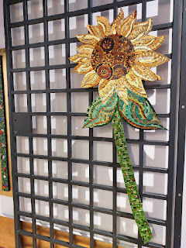

I thought these Nativity sets made from tiny mosaic tiles were gorgeous! Pricey, but gorgeous.

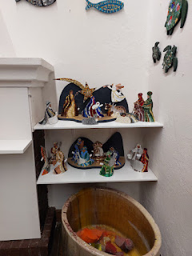

And I am obsessed with this rainbow Tree of Life mosaic . . . I don't know the price, but when I go back to Ravenna next week (with a few friends), I'll check to see if it's off-the-rails or not.

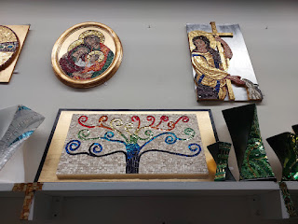

Before I needed to make a purchase, the clerk was in this part of the shop, working on a mosaic project with all of her supplies behind the desk. Notice her huge yellow lab asleep under the desk . . .

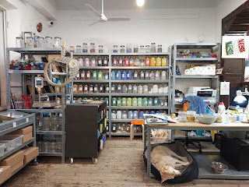

Scott thought this was a good spot to take a photo of me, on a nearby street . . . so I obliged.

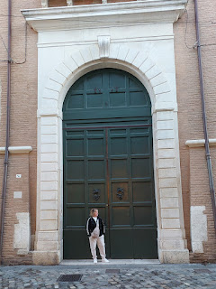

As we walked around, looking for a nice place to eat, we ran into the missionaries!! We offered to buy them dinner, which they happily accepted, so we found a nearby kebab shop because it's Scott's favorite. The mosquitoes were out in abundance as we ate outside, but lucky me - I had on long sleeves and pants this time, so HAH! Take that, ya little blood suckers . . .

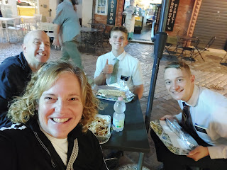

We had a great visit with the missionaries! When it was time for them to go, we walked back to where we parked the car, passing the Basilica on the way. This time it was all lit up in elegant fashion.

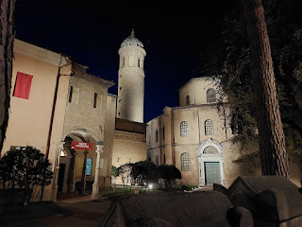

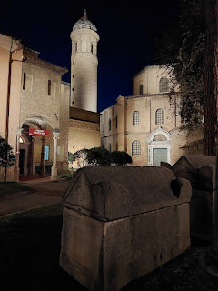

Day Two:

After a pleasant breakfast at the hotel/restaurant, we walked next door to visit the Sant' Apollinare Basilica in Classe. There is a huge meadow in front of it, with bronze water buffaloes greeting the morning sun . . .

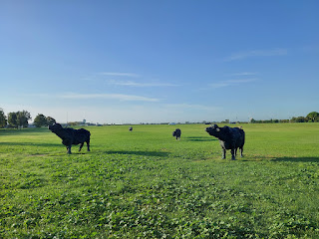

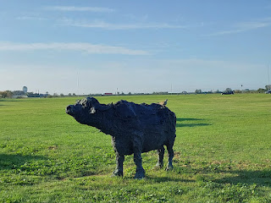

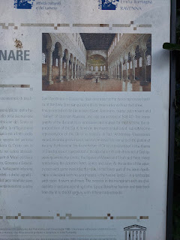

As described in the sign above, this Basilica was consecrated in 549 AD.

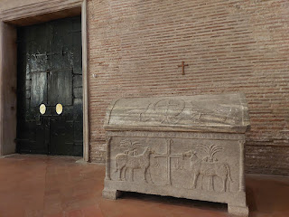

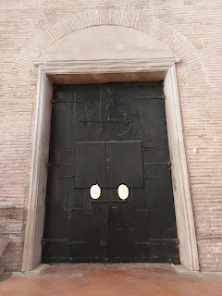

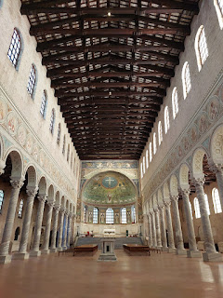

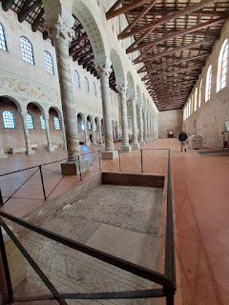

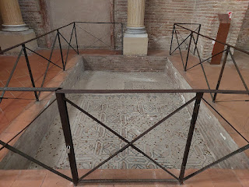

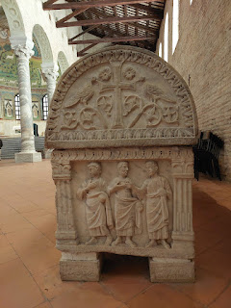

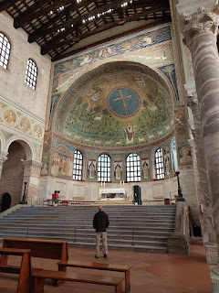

I particularly loved the mosaic panels in front of where Scott was standing in the photo above. There are references to Christ, of course, but there are also sections with Melchizedek and some of the other "lesser known" ancient prophets, such as Elijah. I've included some close-ups of these below, along with some descriptions that were provided as part of the self-guided tour.

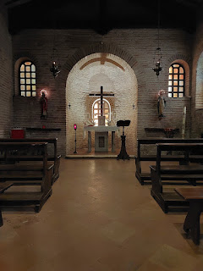

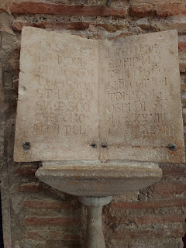

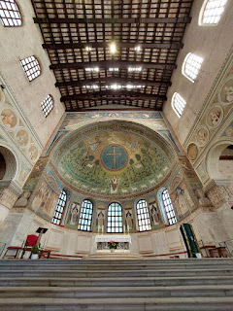

It may be hard to see in the photo below, even after you zoom in, but on the right of the large blue cross is a "bust" of Elias, also known as Elijah. Elias is the Greek form of the name, and Elijah is the Hebrew form of the same name. You can also see in the lower right, a panel depicting Melchizedek, Abel and Abraham - offering their symbolic sacrifices.

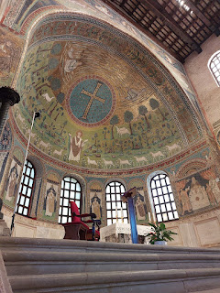

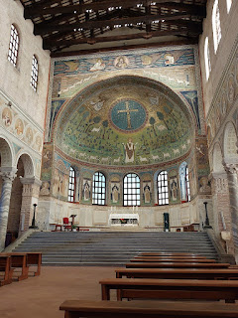

An interesting, although shocking item to note, is that on first glance, it looks as though it is Jesus Christ below the cross, with the 12 sheep turning toward him as the Central Figure. But no . . . it is St. Apollinare. (!) He is depicted as the one whose words brought the 12 tribes to come to know Jesus. Hmmm. Jesus Christ is placed at the very top, with angels and lions to his right and left. I do like that He is at the top, but sadly He is less noticeable up there. The eye is definitely drawn to what looks like Jesus as the Good Shepherd, only it's

not

Him . . .

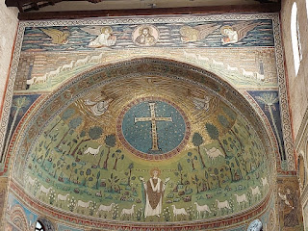

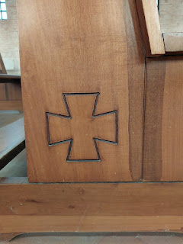

The first few signs are about the history and architecture of the building, plus a few explanations about some of the panels and features and what they represent. Next to each Italian paragraph is an English paragraph, too.

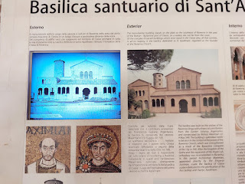

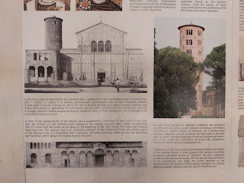

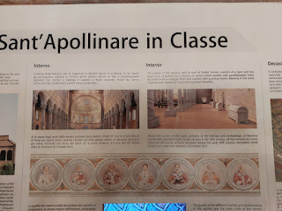

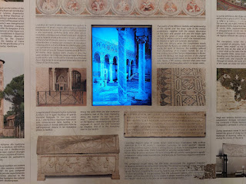

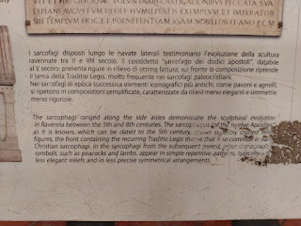

This next sign explains a bit more about that scene that I mentioned above, with the Saint as the central figure.

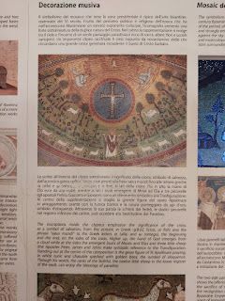

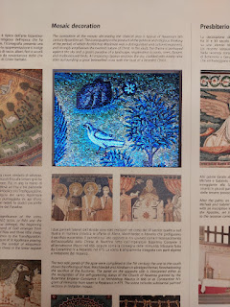

Portraits of Ravenna Bishops of long ago . . .

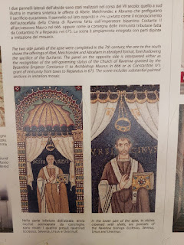

A description of the small mosaic of Christ, along with the evangelistic symbols to his right and left...

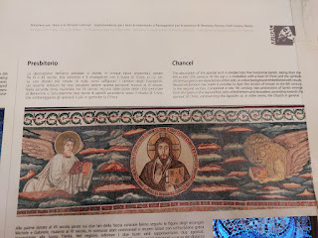

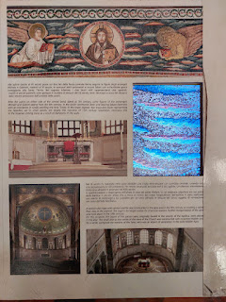

A close-up of Melchizedek, Abraham, and Abel . . .

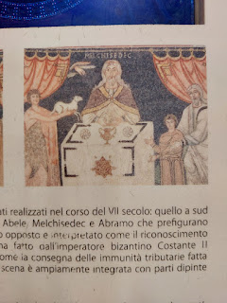

Video of a slow and careful look at the main area behind the pulpit: (30 seconds)

https://photos.app.goo.gl/VpmCej4mVSvLcwaj6

While this Basilica was quiet and beautiful, it didn't evoke quite the same feelings as the Basilica in downtown Ravenna did. I'm not exactly sure why, though. Maybe it was the portrayal of the Saint as the main figure in that big, beautiful mosaic panel that caused a bit of a rift for me. Yes, there are many people through all the dispensations of time who have turned people's hearts to Jesus Christ, but we should never portray any of those people to be

above

or

more central

than Jesus Christ, Himself.

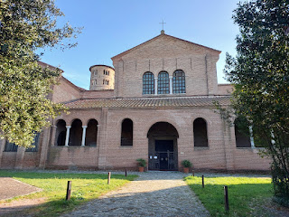

Time to continue our journey . . .

This is a snapshot of some of the places I researched ahead of time and decided we needed to stop for a visit on our way to Rome. I spent a lot of time reading travel blogs and sifting through each town's offerings before settling on Pesaro and Ancona.

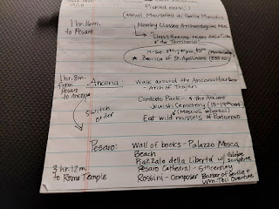

Pesaro, Italy:

(pronounced like PEZZ-a-roh)

The reason this place popped out to me in my research was because it had some very fun offerings: it is not only the birthplace of Rossini (the famous composer), but it also has some unique spots for photography.

*Note: If you're a fan of classical music, this next section is for you. If you're a fan of Rossini, this section is especially for you! (**I chose to come here mainly for my Dad, who I know is a fan of classical music - and also the William Tell Overture.)

After finding a good parking garage close to where we wanted to be, we only had to walk about 5 minutes to get to the Rossini House. (Casa Rossini)

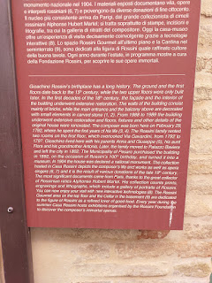

Giaochino Rossini was born here in 1792. He lived on the first floor (where the little balcony is), along with his parents, his aunt, and his grandmother. Pesaro purchased the building in 1892 (Rossini's 100th birthday) and turned it into a museum.

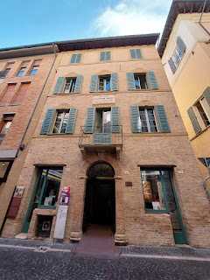

You may be asking, who is this composer named Rossini? And what makes him so special?

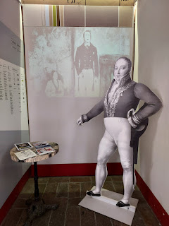

Well, have you ever heard of the William Tell Overture? He wrote it.

And have you heard of the song, Barber of Seville? He wrote that one, too.

When I was growing up, I lived for Bugs Bunny and all of his cartoony friends. One of the most memorable cartoon episodes was where Bugs Bunny was acting as a barber to Elmer Fudd. He foamed him up, steamed his face with hot towels, and groomed Elmer's huge bald head, all while the music to the Barber of Seville played in the background.

Watch the Bugs Bunny scene here: (2 minutes, 35 seconds)

https://www.youtube.com/watch?v=lucXbsbRpw4

Video of the current-day "stage set" for the Barber of Seville in the Rossini House: (10 seconds)

https://photos.app.goo.gl/sNqYoVQh16ZBBQxK7

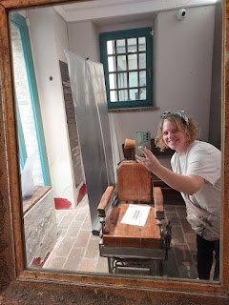

A couple busts of Rossini . . .

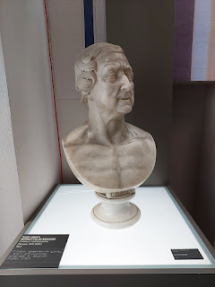

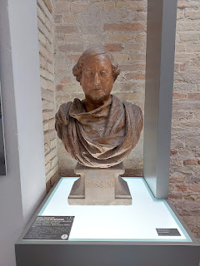

Rossini's father . . .

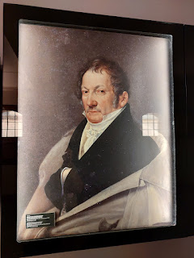

Rossini's mother . . .

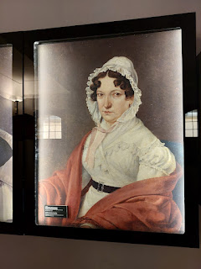

Known as the "State of Souls" Register, this next document is sort of like a US Census Record, but it was made by the local Parish so it had more of a religious purpose in documenting who lived in each house. Taken in 1794, the Rossini Family is listed in the right-hand column, in the center section. It shows Rossini's grandmother, his parents, his aunt, and himself at 2 years old.

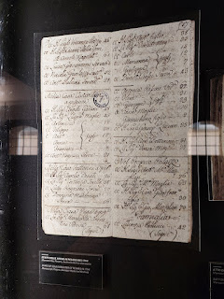

Some of Rossini's original compositions . . .

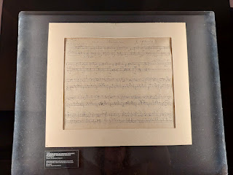

While I couldn't find a sign in this room to verify, this COULD have been the room where Rossini grew up. It was a good size and it was on the correct floor of the building.

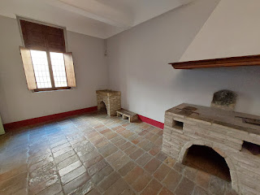

There was a different song playing in each of the several rooms. It was a little dizzying to go from one room to the next, with music piping through the speakers, but how else could you share his music with the patrons? By blaring as many songs as you can, of course!

Short video of the end of one of the songs: (9 seconds) (Sorry - I wish I had gotten more of it)

https://photos.app.goo.gl/ZCNy77PHYRTuJwqF9

Rossini became very famous at an early age, and moved to London by the time he was 30. This next sign explains just how famous he was in 1823 . . .

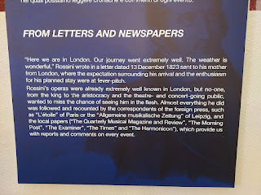

A portrait of Rossini in 1824 (he was 32 years old) . . .

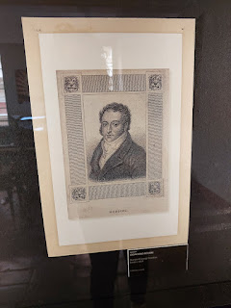

He was known to be a lover of food, which may have contributed to his roundish figure later in life.

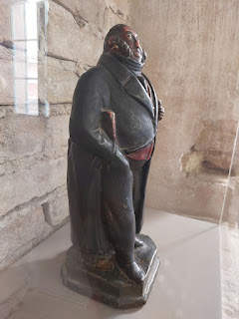

Giaochino Rossini - in January of 1824 in London . . .

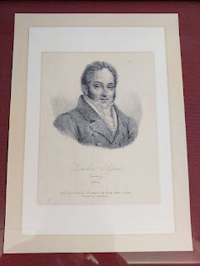

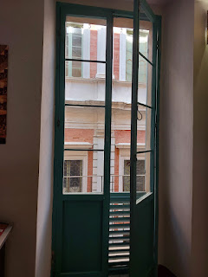

Rossini died in 1868 at the age of 76 . . . this sign tells a little more of the circumstances of his death . . .

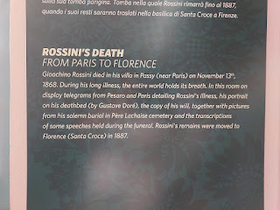

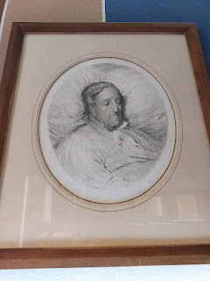

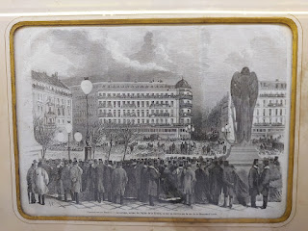

Above: A portrayal of the funeral proceedings.

Below: I think that might actually be Rossini in the open casket!

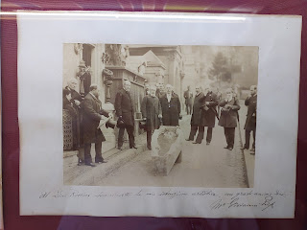

And apparently, I didn't visit the rooms in the correct order, so we're going to backtrack here . . .

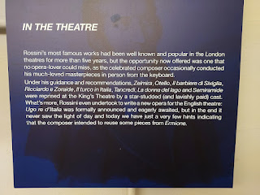

Above: Rossini began combining his musical compositions with several beloved opera performances in London, each with "star-studded" casts.

Below: Rossini's ACTUAL piano!! The sign below describes how it came to be his, and also gives some interesting details, such as where the "damper" is.

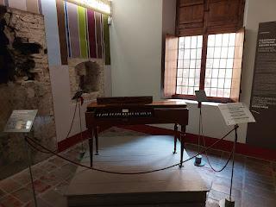

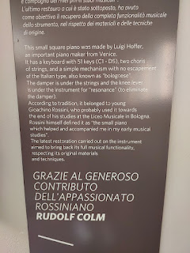

Original sheet music for "Barber of Seville" . . . (along with some close-ups) . . .

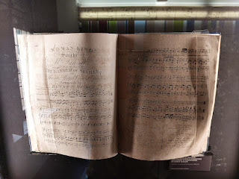

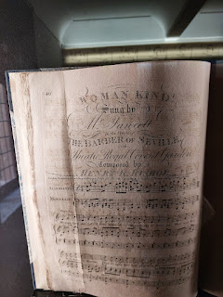

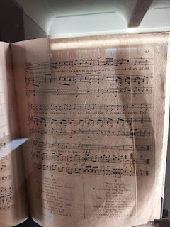

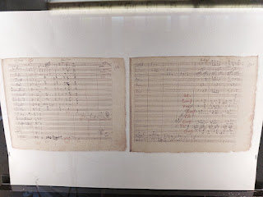

This beautiful lady is Madame Pasta - and yes, I'm being 100% serious here. Judith Pasta was one of the lead performers in some of Rossini's opera shows. What a name . . . LOL.

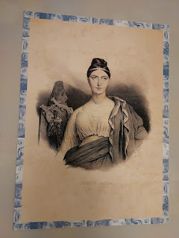

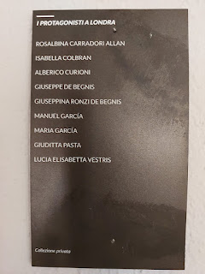

Above: A list of the lead roles in a London performance, including Guiditta "Judith" Pasta.

Below: A summary of some of the expenses for one of the operas performed at King's Theater in London. (Note that Judith Pasta got paid more than Rossini himself . . . )

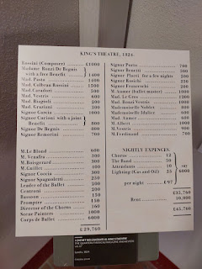

Video looking down onto the street below from the Rossini House (see if you can find Scott, who wasn't interested in coming inside with me): (12 seconds)

https://photos.app.goo.gl/d9dNdLwtSYewQQwf6

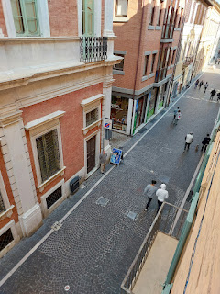

Just a couple more things from the Rossini House . . .

I got a kick out of this cartoon-version of Rossini, with all his instruments flying everywhere, and music exploding out of the cannon (a nod to the William Tell Overture). It appears to be signed by Rossini with a note at the bottom, dated 28 June 1864.

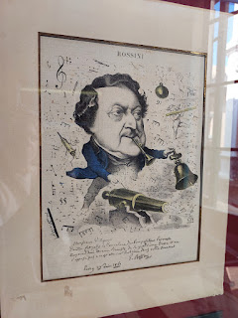

I wonder if his parents were musically gifted. And I wonder if he ever came back to his childhood home and played something wildly entertaining on the piano, and maybe some friends and neighbors gathered below to listen to the free concert out the window . . .

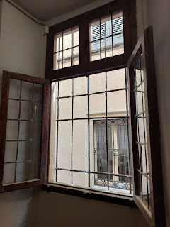

Another framed original musical score . . .

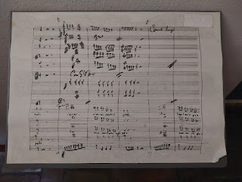

This was a delightful little paper puppet scene inside of a "box", illustrating part of Rossini's lavish and very successful life . . .

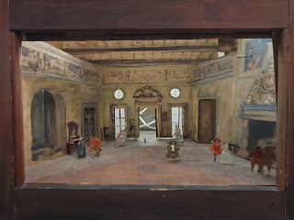

On the way out, if you felt so inclined, you could purchase a memento such as a robust ceramic Chef Rossini, or a side-burned Rossini mug, LOL.

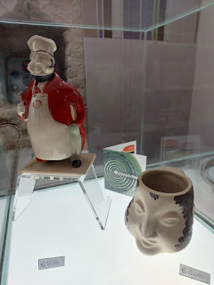

Across the street from the Rossini House was a breezeway that led to an interesting courtyard. This was on my list of things to see in Pesaro - a giant wall of BOOKS!!!

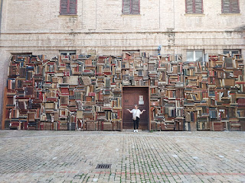

A sign in the courtyard describes how this was set up to honor past performances that took place at the 1997 Rossini Opera Festival. It was actually part of the set! And yes, those are actual books . . .

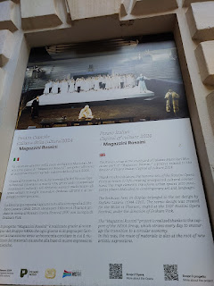

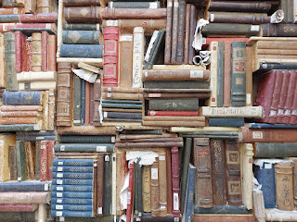

Some interesting and beautiful statues nearby . . .

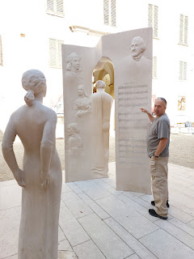

Scott stared at this one for a long time. I patiently waited for him, and then I finally asked what he was thinking about. He was just completely enamored with the artistry and perfect geometry that was used to make it. XOXO

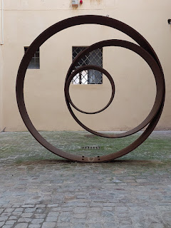

We passed by this very rare WWII Memorial Wall. Italians don't generally speak of or refer back to "that" war. For the most part, they are embarrassed and ashamed of Mussolini, their dictator at the time. But here was a wall of portraits of those who had contributed in the greatest way possible, with their very lives.

At the top of the memorial, the caption translates to: "Eternal Glory to Those Who Fell for Freedom".  And just underneath, these powerful words: "Partisans and Civilians Fallen in the War of Liberation 1943-1945." I saw the faces of a few young children included with the many men and women of Pesaro.

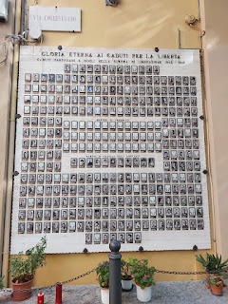

From the Memorial, you can see all the way down the street to another item that was on my list of things to see in Pesaro . . . a bronze globe on a sea of "glass". (a replica of the one in Rome)

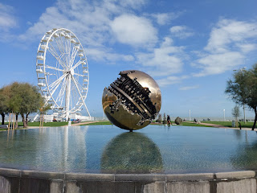

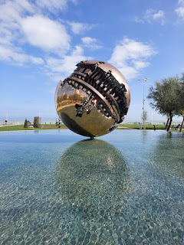

Sadly, all we did was stand briefly to look over the railing toward the beaches. We had a long way to travel that day, and so it was time to say goodbye. I really loved this town a lot.

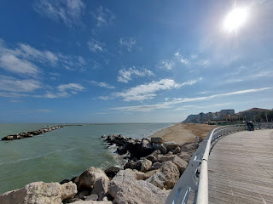

Pesaro was named the Italian Capital of Culture in 2024, not just because of their attention to and preservation of music through the years. They have much more to offer . . .

They host an annual Rossini Opera Festival

They are known for fresh local seafood, including: Adriatic fish, mussels, and squid.

They have 7 km of sandy beaches - many with a "Blue Flag" distinction (cleanliness + water quality)

They have several museums and art offerings

They have the distinction of being a UNESCO Creative City of Music

Beautiful nature reserves surround the city

Hiking trails through the Parco Naturale Monte San Bartolo, with sweeping views above the Adriatic Sea below, and trails that lead down to some of the beaches

An environmental/education park devoted to falcons, with shows twice daily, and held inside a medieval fortress and theater.

I was sad to leave Pesaro so quickly . . .

Our next stop was

Ancona

. It turned out to be a major disappointment, but not because Ancona itself was the disappointment. Circumstances got in the way of our visit, so we didn't spend much time there at all.

Ancona is HUGE. Much bigger than we thought it would be, the city seemed to stretch across several hills and valleys, sprawled out for several kilometers. It is a port city, where huge ships are either bringing passengers and cargo, or they're picking them up.

In my research, I was particularly drawn to the harbor district. There is a giant arch there, named Trajan, built in 115 AD. The harbor is supposed to be a nice place to stroll, but on the day we arrived, everything was completely blocked off. The police had set up a lengthy perimeter and we were barely able to get into the parking garage, having to get permission first.

When it was clear that we would not be able to walk around the harbor, we set off to at least have a nice lunch at the highly-rated restaurant I had chosen ahead of time. But even that turned out to be a wash. First, the policemen told us we had to go a different route, we could not walk down the main street that is adjacent to the port. As we followed his limited alternative instructions, we quickly realized that Ancona is the Italian version of San Francisco with very steep and narrow streets. We had to go a little slower on my account because I was still recovering from my sickness, and my breathing was a little more cumbersome than usual.

We ended up on a tiny little street high above the port, which gave us some nice views.

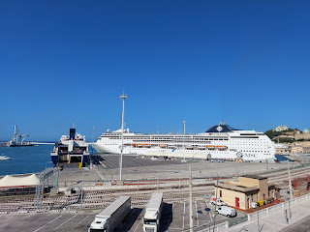

We walked about 10-12 minutes, staying close to the directions on Google Maps, while delicately steering clear of the police perimeter that extended for what seemed like forever. To this day, we have NO IDEA why everything was blocked off. We reasoned that it couldn't have been for the passenger ship that was docked, because how would the businesses in that area ever survive if each time a cruise ship came in, nobody could go to work or even open up their shops? We didn't see crowds gathering for a parade or anything like that, either. Our best guess was that maybe someone really important was coming in, and they had to clear the area for their protection . . . Who knows.

Video looking down at the harbor: (26 seconds)

https://photos.app.goo.gl/urvaQyeSSBCzGmvM7

When we finally got to the restaurant, unfortunately it was on the very street that was blockaded by the police, so it, too, was closed for the day. So, we turned around. On our way back to the car, we found a little grocery store that was open. We grabbed a few random items and ate them in the car, ha ha. Not quite the delicious lunch that we were hoping for, but at least we didn't starve. Thank goodness for the deli section, with some breaded eggplant and zucchini, along with a very nice quiche and potato salad.

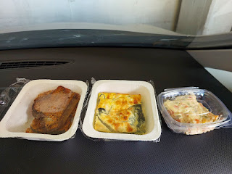

This is the website that drew me to Ancona in the first place:

https://www.visititaly.eu/places-and-tours/things-to-do-in-ancona-like-a-local

It felt like a university town, with a massive harbor, and a San Francisco vibe. I'm not sure we'll ever go back, though, just because the streets were a little stressful. We tried. We failed. And that's okay.

Onward to Rome . . .

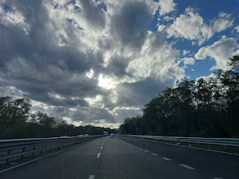

From Ancona to Rome, we passed over and through several mountains. We realized too late that we should have been counting the number of tunnels we drove through . . . And we could not figure out for the longest time what this long, white-ish thing was on a distant mountain. It didn't appear to be snow, or water. The best we could determine was that it was maybe a rock slide or something. The path was enshrouded by clouds at the top, but was a creamy tan color as it "cascaded" down.

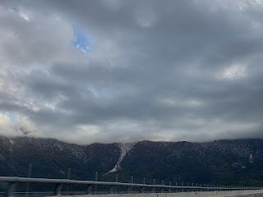

Video as we drove along through the mountains: (13 seconds)

https://photos.app.goo.gl/qUhEFAycdPqso1Xz6

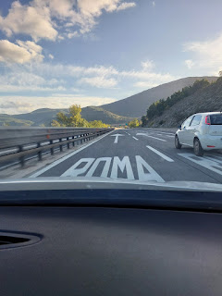

It took us about 3-ish hours to get to Rome, and more specifically, the Rome Temple, where we would be lodging for the night. Temple patron housing is available for free to members of the Church of Jesus Christ of Latter-day Saints who are traveling from a great distance and wish to attend the temple. Scott set it up for us weeks in advance, by making a reservation on their online portal. Something that surprised me a little was that we were in charge of making our own bed - the sheets and pillowcases were folded neatly on the bed upon our arrival. We were in also charge of stripping the bed the following morning, and taking our linens to the laundry room at the end of the hallway. We also needed to empty our trash cans, too. This made things easier for and required less for the maid service to take care of after we checked out.

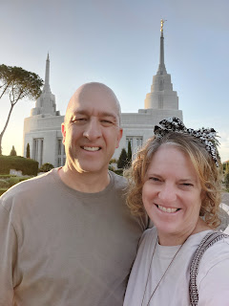

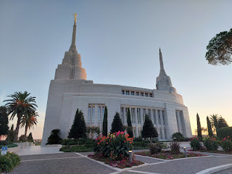

The sun was just beginning to set, which gave us a beautiful opportunity for photos . . .

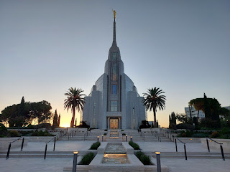

The fountain appears to be gushing directly out of the temple . . .

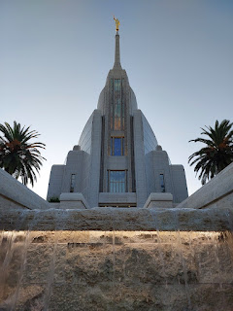

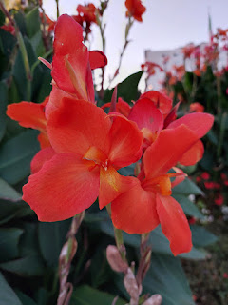

So, umm, I wish we could publicly share the video we took with the drone, capturing the temple with the sun setting behind it. It was some pretty spectacular footage. It felt a little weird when we did it, but it wasn't until we checked into our room at the temple patron housing a few minutes later that we saw in the "welcome binder" that this is forbidden. Oopsies.

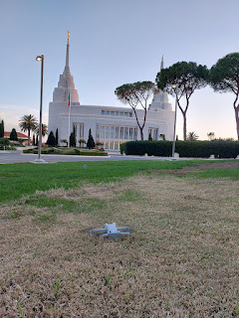

The view from our upstairs window, looking toward the temple spire . . .

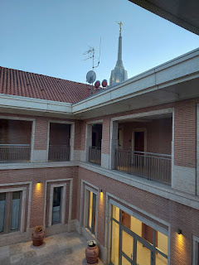

We walked about 5-7 minutes from the temple to get to this yummy little restaurant called "Fracco".

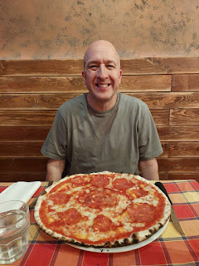

Scott ordered a pizza (he ate that entire thing) while I ordered two chicken thighs with a salad on top, chopped veggies, and a balsamic glaze. It was SO GOOD.

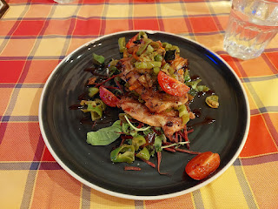

After our tummies were delightfully full, we walked back to the temple to settle down for the night. It had been a long day!! We started the day by touring the Basilica in Classe, then Pesaro, then Ancona, and lots and lots of driving.

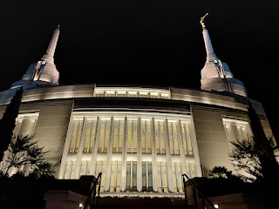

The stained glass windows were so pretty with the lights still on from inside the temple . . .

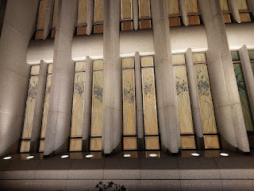

Good night, Jesus, over in the Visitor Center . . .

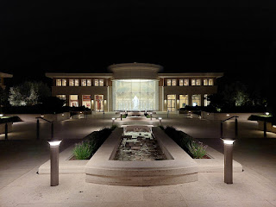

Good night, peaceful temple, beckoning to me to sleep well and then come inside in the morning . . .

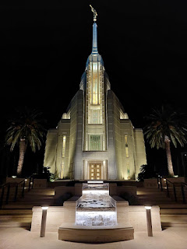

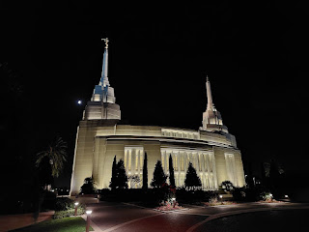

Out of all the places we visited on this big 5-day loop, this was my FAVORITE thing we did. I've never had a sleepover at the temple before, but I absolutely LOVED IT.

